**National University of Computer and Emerging Sciences**



Lab Manual # 6

Programming Fundamentals

(Section BSE-1A)

|  |  |
| --- | --- |
| Course Instructor | Ms. Anoosha Khan |
| Lab Instructor(s) | Mr. Wajahat Ali khan  Ms. Samia Akhter |
| Section | BSE-1A |
| Semester | Fall 2022 |

Department of Computer Science

FAST-NU, Lahore, Pakistan

**Lab Manual**

**Objectives**

The objectives of this lab are to cover the following:

* for loop
* Random Numbers

**Exercise 1:**

The ancient Greeks classified numbers geometrically. For example, a number was called “triangular” if that number of pebbles could be arranged in a symmetric triangle as shown in the figure below. The first ten triangular numbers are 1, 3, 6, 10, 15, 21, 28, 36, and 45. Write a program that takes as input a number N and prints whether it is triangular or not.

**Exercise 2:**

Two dices are rolled. Write a program in C++ that simulates throwing two dice 10 times and returns the sum and product of their face values.

**Exercise 3:**

10. Print the following patterns using loop.

a.

*

**

***

****

b.

*

***

*****

***

*

c.

1010101

10101

101

1

**Exercise 4:**

Write a C++ program that calculates Power (X^Y) of any positive number, you will take X

and Y as input.

if X = 4 and Y = 3 then your code should Output:

**4 power 3 of Number is 64**

if X = 4 and Y = -3 then your code should Output:

**4 power -3 of Number is 0.015625**

**Exercise 5:**

The greatest common divisor (GCD) of two integers is the largest integer that evenly divides each of the numbers. Write a C++ program that gives the greatest common divisor of two positive integers. Take these two numbers from the user.

Remember that the GCD of two numbers can be computed using Euclidean Algorithm as follows

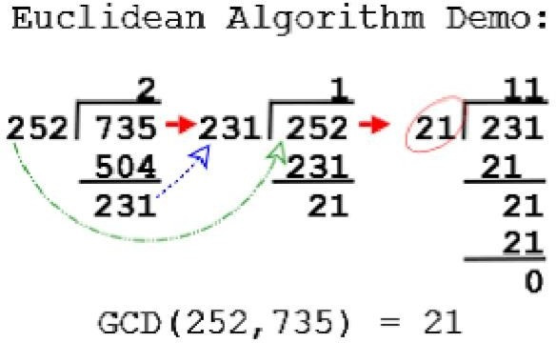

## Sample Run:

**Input num1:** 252

## Input num2: 735

**Output GCD:** 21